Project Design Phase-II
Data Flow Diagram & User Stories

Date | 09 July 2026
Team ID
Project Name | Customer Registry
Maximum Marks | 4 Marks

Data Flow Diagrams:
A Data Flow Diagram (DFD) is a traditional visual representation of the information flows within a system. A neat and clear DFD can depict the right amount of the system requirement graphically. It shows how data enters and leaves the system, what changes the information, and where data is stored.
DFD Level 0 – Customer Registry App (CRM System)
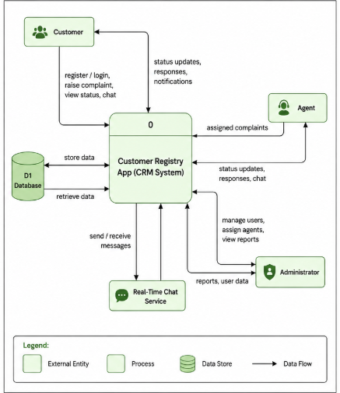
Example: Simplified Flow – Customer Registry App (CRM System)
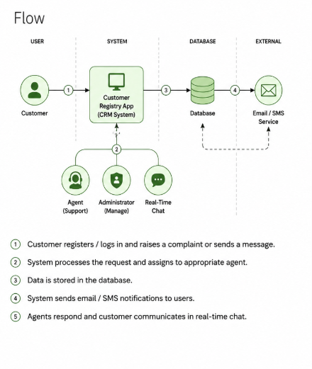

User Stories
Use the below template to list all the user stories for the product.
User Type | Functional Requirement (Epic) | User Story Number | User Story / Task | Acceptance criteria | Priority | Release
Customer | Registration | USN-1 | Register account | Dashboard displayed | High | Sprint-1
Customer | Profile | USN-2 | Update profile | Profile saved | Medium | Sprint-1
Customer | Complaints | USN-3 | Raise complaints | Complaint submitted | High | Sprint-2
Customer | Chat | USN-4 | Chat with agents | Messages delivered | High | Sprint-4
Agent | Complaint Handling | USN-5 | View assigned complaints | Complaints visible | High | Sprint-3
Agent | Status Update | USN-6 | Update complaint status | Status updated | High | Sprint-3
Admin | Agent Assignment | USN-7 | Assign agents | Assignment successful | High | Sprint-3
Admin | Reports | USN-8 | Generate reports | Reports created | Medium | Sprint-4
Admin | Services | USN-9 | Add custom fields | Add custom fields | High | Sprint-4

